PRESS RELEASE
Jihlava, Czech Republic / June 24, 2024

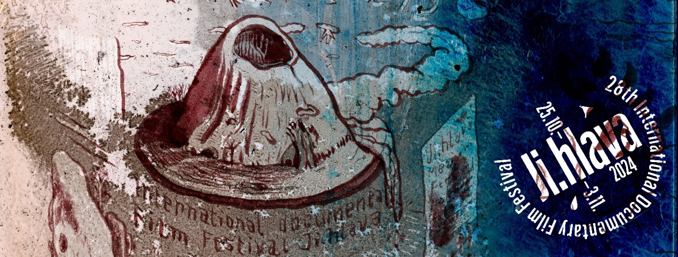

Ten-day Ji.hlava invites to discover

The 28th Ji.hlava IDFF has introduced its poster! "The theme of islands, which is in the center of the Ji.hlava’s visual concept this year, has provoked the human imagination for centuries," says festival director Marek Hovorka about this year's visual, designed by the award-winning book graphic designer and artist Juraj Horváth.

"Islands are a symbol of exploration as well as of enclosure, independence and otherness. All of us have at some point longed to be alone on a desert island for a while, daydreamed about an island vacation, or wondered how we would survive if we were shipwrecked on such an island. Countless literary works, films or even TV competitions take place on islands, and this year at Ji.hlava we will open up to this island imagination," says Marek Hovorka about this year's poster.

The festival, which is being extended from six to ten days this year, will offer, among other, a large retrospective of films by Vít Klusák, Filip Remunda and their production company Hypermarket Film. The Inspiration Forum, Ji.hlava’s discussion platform, will offer an expanded programme: it will focus on the topics of war, immunity, forest and the relationship between new technologies and leisure. Early bird visitor as well as industry accreditations for the 28th Ji.hlava IDFF are now available.

More reruns, more comfort

The Ji.hlava International Documentary Film Festival, which will last for ten days this year, will take place from October 25 to November 3 and will then continue online for 14 days. “The extension will make the festival more open to the visitors and we also want to use the multiple screenings of selected films to reach new audience groups – so in addition to the Ji.hlava for Kids and Ji.hlava Vibes programmes for children and teenagers, we plan to work with the elderly or people with various health disabilities," says Hovorka.

Czech Dream twenty years later – a retrospective of Vít Klusak and Filip Remunda

This year’s Ji.hlava will offer a major retrospective of directors Vit Klusák and Filip Remunda and their leading Czech production company Hypermarket Film. The festival will present almost two dozen films, including the award-winning Czech Dream (2004) about "the hypermarket that didn’t exist", which premiered twenty years ago this year.

“Czech Dream is rightly one of the most important Czech documentaries ever made. The filmmakers have built on its success with more films and have also championed works of other important Czech directors, such as Adéla Komrzý, Apolena Rychlíková or Erika Hníková," says Marek Hovorka when introducing the retrospective. "We are very much looking forward to the fact that a new generation of viewers will be able to meet these films and their creators this autumn in Ji.hlava", adds Hovorka.

"On the occasion of the 20th anniversary of the first release of Czech Dream, we have prepared a digitally remastered version of our first feature film. This version will have its premiere in Jihlava and after the festival Czech Dream will be released in cinemas. In 2003, Vít and I founded Hypermarket Film exclusively for the production of one single film. In the end, however, we did not shut down the company, but together with Vít and our wonderful producer Tereza Horská we opened it to our films and the films of our filmmaker friends, whose work and creative thinking we respect. I am glad that this year in Jihlava we will show a selection of films from those 21 years," says Filip Remunda about the retrospective.

The Inspiration Forum presents the themes and personalities

Four thematic days and three collective gatherings will be offered at this year's Ji.hlava Inspiration Forum. It will traditionally focus on topics that represent the greatest challenges of civilization today: this year the discussions will deal with technology and leisure, forest, war and immunity. Dozens of guests from across the world will head to Ji.hlava.

Among the confirmed participants of the Inspiration Forum is British environmental philosopher Timothy Morton. "It's hell, but it's not the end of the world," says Morton on the subject of the climate crisis, the state of which he reflects on in his latest book, Hell, which he will be presenting at Ji.hlava. The topic of leisure will be opened by a renowned Canadian-British couple: economist and philosopher Nick Srnicek and feminist theorist Helen Hester, who this year published their long-awaited book After Work, which examines the impact of technology and gender division in domestic work.
The 28th Ji.hlava IDFF will take place on October 25 – November 3, 2024. Discounted Early Bird visitor and industry accreditations are now available.
More information at www.ji-hlava.com and on the festival’s Facebook and Instagram profiles.
Download the Visual of the 28th Ji.hlava IDFF.

For more information please visit www.ji-hlava.com or contact Ji.hlava IDFF at pressservice@ji-hlava.cz.

